Karnaugh Maps in Word
Template:
 | cd
ab |  | 00 | 01 | 11 | 10
 | 00
 | 01
 | 11
 | 10
F(a,b,c,d) =
This will save you the trouble of creating a table format on your own. You can simply copy and paste the template into your own document and fill it out. It’s easy to change the terms from a,b,c,d to w,x,y,z or whatever you need. Below are some grouping examples.
 | cd
ab |  | 00 | 01 | 11 | 10
 | 00 | 1 |  |  | 1
 | 01
 | 11 | 1 | 1 | 1 | 1
 | 10 | 1 |  |  | 1
F(a,b,c,d) = ab + b’d’
Where the groups don’t overlap, it’s simplest to just use shading. Too bad it’s not always that simple.
 | cd
ab |  | 00 | 01 | 11 | 10
 | 00 | 1 |  |  | 1
 | 01
 | 11 | 1 | 1 | 1 | 1
 | 10 | 1 | 1 | 1 | 1
F(a,b,c,d) = ??
When the groups overlap, you’ll need to use a painting program. Paste the map into it and use the program’s shape tool to draw a box around the groups. Paint is quick and dirty and gets the job done, but it’s won’t let you paste the map directly; you’ll have to take a screen shot and paste that.

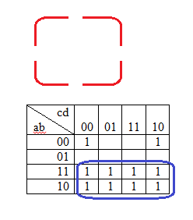
In an unused part of the image, you can draw a rectangle and break it up into corners, like the red one above. Then you can paste those corners to capture groups going off the edges. Use Transparent Selection to get just the rectangle parts and paste them without obscuring the map your pasting them over:
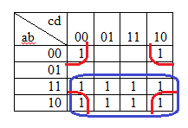
F(a,b,c,d) = a + b’d’
As you can see, then all you have to do is select the part of the image you want to put in the document, Ctrl-C to copy it, and Ctrl-V to paste it into your document.

