Shell Eco-marathon

By
Jericho Alves, Benjamin Kurtz, Moneer Al-Jawad,
& Daniel Chief
Team 14

Problem Formulation and Project plan
Document

Submitted towards partial fulfillment of the requirements for
Mechanical Engineering Design I – Fall 2013

Department of Mechanical Engineering
Northern Arizona University
Flagstaff, AZ 86011

CONTENTS

- Need Statement………………………………...…………………………………2
- Problem Definition………………………….……………………………………2
- Chassis / Monocoque……………………………...…………………………..…2
- Safety…………………………………………………………………...……...…3
- Steering………………………………………………………...…………………4
- Project Planning…………………………………………………….……………5
- Summary……………………………………………………………….…………5
- References……………………………………………………………..…………5

NEED STATEMENT

One of the main issues our society is facing is the constant increase in the temperature of the earth’s atmosphere, also known as global warming. A rise in the temperature in the atmosphere can cause ice to melt around the Earth’s poles, a rise in sea level, and an increase in rainfall and snowfall worldwide. This phenomenon is mainly caused by greenhouse gases produced by the burning of fossil fuels. According to the United States Environmental Protection Agency, 28% of greenhouse gas emissions come from burning fossil fuels in transportation. Oil refined as gasoline to fuel cars, trucks, and other highway vehicles is the main fossil fuel used in transportation.

The Shell Eco-marathon competition is designed for students to find innovative solutions in transportation to help reduce the release of greenhouse gas emissions in vehicles. This includes finding alternative energy sources as well as optimizing the energy sources we have today.

PROBLEM DEFINITION
Goal:
Our goal is to design, build, and compete with a car prototype that maximizes fuel efficiency of an internal combustion engine to compete in the Shell Eco-marathon Americas competition in Houston, TX. The design of the chassis and steering systems will minimize weight, maximize aerodynamics, and follow all regulations of the competition under a low budget.

Focus:
Our focus is on the design of the chassis and steering as well as covering all safety requirements of the driver and the car.

OBJECTIVES

Objective | Benchmark | Unit of Measurement
Lightweight | Chassis Weight | Kilograms
Rigid | Deflection Under Load | Centimeters
Aerodynamic | Drag | N
Low Cost | Cost | US Dollars

CHASSIS / MONOCOQUE
The following section will outline some specific needs and constraints relating to the Eco-marathon vehicle chassis and fairing. These constraints were derived from the Shell rulebook Chapter 1.

Needs:

Current vehicle technologies need to be reassessed to increase overall fleet fuel efficiency.

Global Need: The eco-marathon vehicle should be safe to operate and protect driver in the event of a collision or rollover.

Constraints
- Dimensional Constraints (Article 39)
  - Length: 350cm Maximum
  - Width: 130cm Maximum
  - Height: 100cm Maximum
  - Track Width: 50cm Minimum
  - Wheelbase: 100cm Minimum
  - Height/Width Ratio: 1.25 Maximum
- Chassis/Monocoque/Fairing Constraints
  - The chassis must incorporate a roll bar that extends 5cm above the drivers head, and past the width of the drivers shoulders with the driver in the standard driving position with the seatbelts fastened. The roll bar must be able to withstand a 700N load without deflecting.
  - The vehicle fairing must cover all drivetrain associated parts.
  - The cover around the engine must be easily removable to facilitate inspection access
  - Vehicle with wheels mounted inside the faring must have a bulkhead that separates the wheels from the driver.
  - The vehicle must have a full floor that will prevent the driver from any contact with the ground at any point during normal operation.
  - Vehicle windows must be made from a material such that in the event of an impact, they do not break into smaller shards.
  - The vehicle fairing must not impede driver visibility directly ahead of the vehicle or 90 degrees to either side of the vehicle’s longitudinal access.
  - Any active aerodynamic apparatus are specifically prohibited.
  - Vehicle must be designed to allow the driver to vacate the vehicle in less than 10 seconds, starting from a fully harnessed position.
  - The driver access portion of closed body vehicles must be easily accessible from both inside and outside of the vehicle and must be possible to open without tools. Exterior latches must be clearly marked with red arrows.

SAFETY
The objective is to minimize risks by creating safe vehicle that includes all safety essentials.

Safety will be divided in two major sections, Driver Safety and Vehicle Safety. These sections are created to satisfy the organizer’s requirements.

- Driver Safety
  - Seat Belt: it has to have 5 mounting points meets all together in single buckle. Firmly, mounting points have to be attached to the vehicle main structure.
  - Helmet: full face or three quarters must be worn all the time inside the vehicle during practice or actual competition.
  - Vehicle Access: suitable space for driver so he/she can exit the vehicle without assistance. Besides, to have enough space for the driver’s comfort.
  - Exhaust System: the exhaust gas must be evacuated outside of the vehicle to insure the safety of the driver.
  - Insulation: engine must completely be insulated from the driver to eliminate the heat produced from the engine.
  - Fire Extinguisher: must be on-board at all time
Each vehicle must have a valid hand held fire extinguisher and driver must acknowledge the use.

- Vehicle Safety
  - Inspection: vehicle will be inspected by the organizer to ensure the safety of the components.
    - Parts: must be firmly attached together.
    - Frame: must be settled and installed correctly.
    - Chassis: must be rigid.
        - Brakes: two braking systems must be installed independently to increase the efficiency and to secure the vehicle.
    - System 1 must act on the front wheels only.
    - System 2 must act on the rear wheels only.
  - Emergency Shut-Down System: vehicle must have two independent shut-down switches. Both must be operable from the interior driver position and the exterior of the vehicle.
  - Fire Extinguisher: must be on-board at all time.
Another fire extinguisher must be present in the team’s garage area.

STEERING

Steering Constraints (Article 41 and 42)
- Tires and Wheels
  - All types of tires and wheels are allowed.
  - Rims must be compatible with tires.
  - Wheels inside the vehicle body needs to be isolated from the driver by a bulkhead.
  - Wheels are required not to come in contact with any other parts of the vehicle.
- Turning Radius
  - Front wheel or rear wheel steering is allowed.
  - If rear wheel steering is used, the driver should be able to locate the straight ahead position.
  - The turning radius must be sufficient to safely make turns on the track.
  - If turning radius is insufficient the organizers may recommend to drive the slalom course, which has a turning radius of 8 m.
  - Indirect electronic steering system is permitted, providing they are operated by a steering wheel or something similar.

PROJECT PLANNING
The Gantt chart shown in Figure 1 gives an initial idea of the timeline we anticipate following. The small scale production of composite parts is extremely time consuming which is why there is a large amount of time allotted to chassis and fairing construction. The front and rear subframes must be designed around the drivetrain, steering and braking systems. The fairing design requires all other systems to be finalized in order to ensure the fairing covers all parts defined by the Shell rulebook.
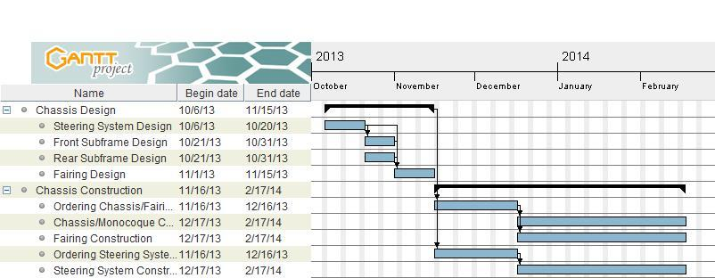

Figure 1: Chassis Design and Construction

SUMMARY

During the initial phases of this project we have determined the customer needs, team goals, quantifiable objectives, and design constraints. The team has developed an initial timeline to ensure progress is being made, and that the vehicle will be complete and thoroughly tested before the competition. From this point forward the team will continue to research possible system components and develop various concepts for vehicle design.

REFERENCES
Shell Eco-marathon, "Offical Rules 2014 Chapter 1,"http://s01.static-shell.com/
content/dam/shell-new/local/corporate/ecomarathon/downloads/pdf/sem-
global-official-rules-chapter-1-2014.pdf, 01 Oct. 2013.

"Sources." EPA. Environmental Protection Agency, n.d. Web. 03 Oct. 2013.

