Shell Eco-marathon

By

Jericho Alves, Benjamin Kurtz, Moneer Al-Jawad, & Daniel Chief
Team 14A

Concept Generation & Selection
Document

Submitted towards partial fulfillment of the requirements for

Mechanical Engineering Design I – Fall 2013

Department of Mechanical Engineering
Northern Arizona University

Flagstaff, AZ 86011

Contents
- Project Overview 2
  - Need Statement 2
  - Problem Definition 2
- Chassis/Fairing Design 2
  - Design Considerations 2
  - Preferred Construction Method 2
  - Possible Design Alternatives 2
- Safety Designs 3
  - Side Sprinkler System 3
  - Overhead Sprinkler System 4
  - Extended Hose Fire Extinguisher 5
- Steering Designs 6
  - Rack and Pinion Steering 6
  - Worm and Roller Steering 6
  - Worm and Nut Steering (Recirculating Ball Type) 6
- Summary 7
- References 7

Project Overview

Need Statement

One of the main issues our society is facing is the constant increase in the temperature of the earth’s atmosphere, also known as global warming. A rise in the temperature in the atmosphere can cause ice to melt around the Earth’s poles, a rise in sea level, and an increase in rainfall and snowfall worldwide. This phenomenon is mainly caused by greenhouse gases produced by the burning of fossil fuels. According to the United States Environmental Protection Agency, 28% of greenhouse gas emissions come from burning fossil fuels in transportation. Oil refined as gasoline to fuel cars, trucks, and other highway vehicles is the main fossil fuel used in transportation.
The Shell Eco-marathon competition is designed for students to find innovative solutions in transportation to help reduce the release of greenhouse gas emissions in vehicles. This includes finding alternative energy sources as well as optimizing the energy sources we have today.
Problem Definition
  - Goal:
Our goal is to design, build, and compete with a car prototype that maximizes fuel efficiency of an internal combustion engine to compete in the Shell Eco-marathon Americas competition in Houston, TX. The design of the chassis and steering systems will minimize weight, maximize aerodynamics, and follow all regulations of the competition under a low budget.
  - Focus:
Our focus is to design the chassis, steering system, safety systems of the car.
- Chassis/Fairing Concept Generation
  - Design Considerations
Development of the chassis and fairing or monocoque will be determined by what resources we can secure in the near future. As a team, the initial budget and resources afforded to us are limiting and would likely direct us towards creating a thermoplastic fairing supported by an aluminum frame. If additional sponsors become available, we can make composite structures and move towards a monocoque chassis which is lower in overall weight and also produces less drag.

  - Preferred Construction Method
The ideal chassis construction is a composite monocoque which encloses the wheels completely. The shell is made with two separate plugs. The molds increase the complexity of construction. The main benefit of a composite monocoque, as stated previously, is an extremely rigid yet lightweight chassis. Enclosing the wheels restricts the turning radius, so it is crucial to do extensive analysis prior to construction to ensure suitable maneuverability.
  - Possible Design Alternatives
The first design alternative consists of a tube frame chassis preferably constructed out of aluminum. The frame would run the length of the vehicle and support all suspension and driveline components as well as the roll bar. This design is the least preferable method as it weighs the most. The main benefit of this design is that we can manufacture the entire frame in house with the aid of NAU staff. The fairing can be made from a single plug and mold. The fairing can be a streamlined half body or possibly made from flat flexible sheeting. Again this design is a compromise in order to maintain a short build time with little to no resources outside of the engineering department at NAU.
The second design alternative is a monocoque chassis with unenclosed wheels. This design is a simple yet agile design, which could easily integrate subsystem design changes without redesigning the chassis itself. Construction of an unenclosed wheel monocoque chassis is accomplished by making a monocoque chassis similar to the method listed above, but keeping the wheels outside of the shell. In the instance that hubs, brake systems, or steering components need to be redesigned to increase performance or shed weight, they can be changed with minimal impact to the shell. The construction would again require resources outside of NAU, but is much less complicated than creating a chassis with wheel fairings.
- Safety Concept Generation
Shell requires all competitors to follow strict safety regulations. A fire extinguisher must be installed in every vehicle during the competition. We want to ensure the safety of the driver, so we produced three different concepts for potential fire safety methods inside the vehicle.
Each concept contains sketches to show the layout of the system in the vehicle, and is compared in a decision matrix, shown in Table 1, to help determine the final choice. The following is the criteria used to determine the best possible fire prevention system.
Efficiency is defined as how fast the system can put out the fire and how much area it can cover. The relative weight for efficiency is 0.50 because the vehicle needs to be safe. System weight is defined as the total weight of all components of the fire prevention system. System weight is given a relative weight of 0.25 because we are trying to minimize the weight of the vehicle. Simplicity is defined as the ease of installation and lack of interference with other boundaries. The relative weight of simplicity is 0.15 because it is not as important as efficiency or system weight. Cost is defined as the total cost of all fire safety components. The relative weight of cost is 0.10 and is the least concern to our group. Safety is a serious matter, and we need to insure that our vehicle and driver are safe no matter what cost is.
Side Sprinkler System
In this concept, the fire extinguisher will be placed horizontally next to the driver allowing him to press the handle easily at any fire circumstance. A tube will be installed into the nozzle and the tube will be installed along the fairing all around the vehicle. There will be fire sprinklers installed along the tube allowing the fire extinguisher fluid to come off easily at different positions. Also, these positions will insure to cover the whole vehicle parts including the engine since it will be installed at the end of the vehicle, and there will be an insolation wall separating the driver from the engine.
The advantage of this design is that it will cover most of the vehicles parts including the engine. On the other hand, it will be placed at the lower interior side, which will decrease the efficiency of fire elimination. Figure 1 shows a sketch of this particular design and the position of the fire sprinklers.
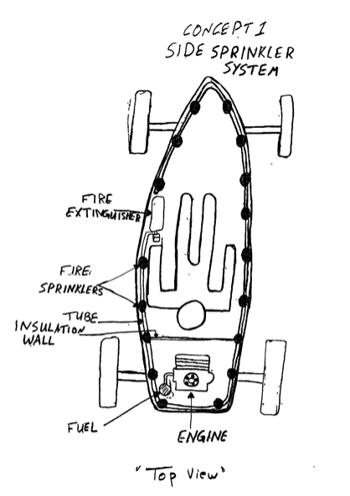
Figure 1: Side Sprinkler System

Overhead Sprinkler System
An overhead sprinkler system is relatively the same as a side sprinkler system, except for the location of the sprinklers.. The fire extinguisher is also installed horizontally next to the driver, but the tube will be placed at the top of the vehicle. Fire sprinkles will be placed along the tube at different locations allowing the fluid to cover the inside of the vehicle including the engine. This concept is more efficient than the side sprinkler system because the fluid can cover a wider area. Figure 2 shows a sketch of the system, illustrating the placing positions of the sprinklers.

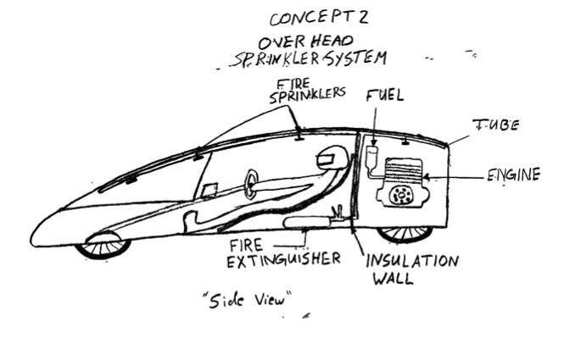

  - Long Hose Fire Extinguisher
This concept is simply a long hose attached to a fire extinguisher. Similar to the previous two concepts, the fire extinguisher is placed horizontally next to the driver and a long hose is clipped to the fairing near the driver’s arm. The placement of the hose allows the driver to easily grab the hose in any fire circumstance. The benefit of the long hose is to allow the driver aim at the target directly. However, since the driver will not have much space to move freely inside the vehicle, his movements will be extremely limited. Also, the driver will not be able to reach the engine boundary in the rear of the vehicle because he will be insulated from the engine by the insulation wall. These are the two major disadvantages for this system concept. Figure 3 below shows a sketch of this concept, illustrating the location of the long hose. The position of the fire extinguisher in Figure 3 is shown vertically, only to display the hose length easier.
Figure 3 (Long Hose Fire Extinguisher)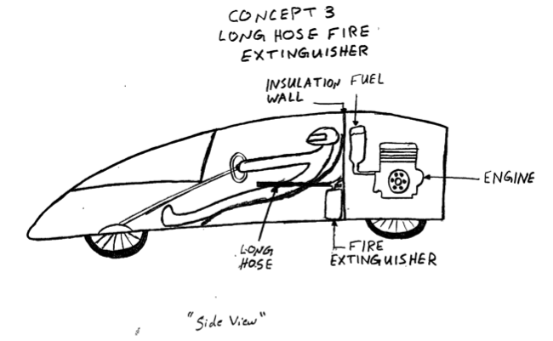
The decision matrix shown in Table 1 describes each concept and helps illustrate which design will be chosen. The number scale of the decision matrix starts at 1 as the lowest value and 10 as the highest.

Table 1: Safety concept generation decision matrix
 | Relative Weight | Side Sprinkler System | Overhead Sprinkler System | Long Hose  Fire Extinguisher
Efficiency | 0.50 | 5 | 8 | 3
System Weight | 0.25 | 3 | 5 | 2
Simplicity | .15 | 4 | 5 | 1
Cost | .10 | 2 | 2 | 2
Raw Score |  | 14 | 19 | 8
Weighted Total |  | 4.05 | 6.20 | 2.35

From this decision matrix, the fire overhead sprinkler system is the best option because it has a higher efficiency compared to the other concepts. It is also not a complicated system and can be built without having major issues. Also, its weight is not considered very heavy resulting our vehicle to be slow. Sprinklers installed on top and sprinklers installed along the side are the highest scoring concepts. this decision matrix shows that the sprinklers installed on top is 53% better than sprinklers installed on the sides.
- Steering Concept Generation
  - Rack and Pinion Steering
Rack and pinion steering is the most common type of steering. Rack and pinion systems are enclosed in a metal tube with the ends of the rack protruding the tube. A tie rod is attached at the end of the system and is connected to the steering arm on the spindle. The steering wheel turns the pinion gear, the pinion moves the rack, converting rotational motion to linear motion. This motion applies force to the tie rod and steering arm. The steering arm is attached to the wheel, which causes the tires to turn. Rack and pinion steering is most common on the front wheel drive vehicle.
The advantages of the rack and pinion are: it has a large degree of feedback and direct steering feel, it has fewer moving parts, the driver has more control, the rack and pinion are smaller and takes up less space. The disadvantages of the rack and pinion: it is not adjustable when it wears, the simple construction causes the transfer of noise and vibration to the driver and passengers, off-roading wears the linkage.
  - Worm and Roller Steering
Worm and roller steering consists of a roller which is meshed with a worm gear enclosed in a box. The roller is shaped like an hourglass so the roller will not disengage when in motion. The worm is located at the end of the steering shaft. An arm, called the Pitman arm, is attached to the roller. The Pitman arm is connected to the steering mechanism which turns the wheels.
Worm and roller steering works when the steering wheel turns the worm, the roller turns with it, forcing the sector and Pitman arm to rotate.
The advantages of the worm and roller steering are: simple in construction, it is easy to build and maintain, there is little effort in turning the steering wheel. The disadvantages of the worm and roller steering: there is a lot of friction between the worm and roller.
  - Worm and Nut Steering
Worm and nut steering, also known as the recirculating ball, is used in older vehicles, off road vehicles and some trucks. The worm gear sits inside a block with a threaded hole in it. The block has gear teeth cut into the outside of it, which engages a gear that moves the pitman arm. The steering wheel connects to a threaded rod. When the steering wheel turns, it turns the bolt. Instead of twisting further into the block the way a regular bolt would, this bolt is held fixed so that when it spins, it moves the block, which moves the gear that turns the wheels. The worm and nut steering is popular among rear wheel drive vehicles.
The advantages of the worm and nut steering are: less degree of feedback, used in trucks and large vehicles where robustness, maintainability and mechanical advantage are important. The disadvantage of worm and nut steering is it there is a dead spot in the middle of the turning radius.
  - Decision Consideration
Cost is defined as the amount of U.S. dollars it will take to purchase or build the entire steering system. Cost is important because we have a budget to maintain. The relative weight for cost depending on sponsors and donations of materials is 0.30.
Space is defined as the amount of area the steering system occupies. In order to reduce drag we will like the vehicle compact without bulky components so the relative weight for space is 0.1.
Efficiency is defined as the amount of feedback and direct steering feel. The ease of making turns around corners while driving the course. The relative weight is 0.45 this is due to the safety of the driver.
Weight is defined as the amount of force an object has due to gravity. The overall weight of the steering system is not as important as efficiency so the relative weight is 0.15.
From the decision matrix, the best design choice for steering is the rack and pinion. The rack and pinion is simple in design. It has good feedback and a more direct driving feel.
 | Relative Weight | Rack & Pinion | Worm & Roller | Worm & Nut
Cost | 0.30 | 8 | 5 | 7
Space | 0.10 | 5 | 3 | 3
Efficiency | 0.45 | 6 | 4 | 2
Weight | 0.15 | 3 | 2 | 2
Raw Score |  | 22 | 14 | 14
Weighted Total |  | 6.05 | 3.9 | 3.9
Summary
The designs selected above were based off of criteria defined by the group. The criterion defined is different for each section. Each section consisted of three concepts and the best concept was chosen. A solid frame monocoque design is chosen for the fairing and chassis section because it is ligh
In order to proceed with the design selection, our team needs to know our initial budget. Unfortunately, the budget for our team is still being worked out by SAE and outside companies. In response, the concepts selected for each of the designs are preliminary. Once we know closer estimate of the resources available for the eco-marathon project, we can continue to work out our designs.
- References
1. "Rack and pinion variable ratio steering gear". Google Patent Search. Retrieved 2007-03-22.
2. Jump up to: ª ^{b} Gear Nomenclature, Definition of Terms with Symbols. American Gear Manufacturers Association. p. 72. ISBN 1-55589-846-7. OCLC 65562739. ANSI/AGMA 1012-G05.
3. Nice, Karem "How Car Steering Works", "HowStuffWorks", Accessed August 13, 2007
4. www.carbibles.com/steering_bible.html

