NORTHERN ARIZONA UNIVERSITY

SAE AERO Design Report

Submitted by
Team: 017
Chase Beatty
Brian Martinez
Mohammed Ramadan
Noe Caro

Faculty Advisor: John T. Tester, Ph.D.

02/06/12
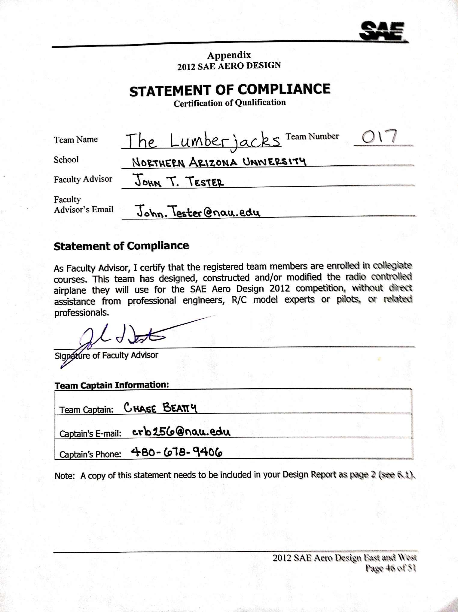

Table of Contents
1.0 Introduction 7
1.1 Objective 7
1.2 Requirements 7
2.0 Design Selection Process 8
2.1 Research 8
2.1.1 Concepts 8
2.1.1.1 Wing Design 8
2.1.1.1.1 Airfoil 8
2.1.1.1.2 Wing Geometry 9
2.1.1.2 Fuselage 9
2.1.1.3 Tail Configurations 9
2.1.1.4 Landing Gear 10
2.1.2 Discussion of Previous Designs 10
2.2 Design Selection Review 11
2.3 Design Selection Process 12
2.3.1 Selection Process for Airfoil Profile 12
2.3.2 Selection Process for Wing Construction 12
2.3.3 Selection Process for Wing Geometry 12
2.3.4 Selection Process for Fuselage 12
2.3.5 Selection Process for tail 13
2.3.6 Selection Process for landing gear 13
3.0 Calculations 13
3.1 Performance 13
3.1.1 Drag Analysis 13
3.1.2 Static and Dynamic Thrust 14
3.1.3Take-off Distance 14
3.2 Stability and Control 15
3.2.1 Stability 15
3.2.1 Control 15
3.3 Aircraft Sizing 17
3.3.1 Wing Geometry and Selection 17
3.3.2 Airfoil Analysis and Selection 18
3.4 Weight Build Up and Analysis 19
3.5 Structural Analysis 20
4.0 Innovations 23
4.1 Construction Process 23
4.2 Design Methodology 23
4.3 Applications 23
4.3 Use of Computer Aided Design 24
4.4 Electrical Design 25
References 26
Appendix A 27
Appendix B 28

List of Acronyms
$torq$ – Torque | $V$ – Airspeed | $Cf$– Coefficient of friction
$S_{ref}-$Wing reference area | $s$ – Servo arm angle from neutral | $AR$ – Aspect ratio
$S_{wet}$– Wetted Area | $CS$ – Control surface angle from neutral | $S$ – Planform area
$b$ – Wing span | $C_{L}$– Lift coefficient | $e$– Oswalt efficiency number
$A$– Cross sectional area | $C_{D}$– Drag coefficient | $Re$ – Reynolds’s number
$L$ – Length | $C_{d}$– Drag coefficient of airfoil | $COG$ – Center of gravity
$C$ – Chord length of control surface | $C_{D,i}$– Induced drag coefficient | $RPM$ – Revolution per minute
$f_{tovt}$-Thickness Ratio of Vertical Tail | $C_{dminvt}$-Minimum Drag Coefficient of Vertical Tail | $Xac$ – Neutrality point
$f_{toht}$-Thickness Ratio of Horizontal Tail | $C_{dminht}$-Minimum Drag Coefficient of horizontal tail | $Xwc$ – Main wing center of gravity location
$M$ – Mach Number | $clh$ – Horizontal Tail Lift Coefficient | $Vh$ – Horizontal Tail Volume
$Clhd$ – 3-D lift coefficient | $α$ – Angle of attack | $ε$ – Downwash Angle
$SM$– Static Margin | $AoA$– Angle of attack | $Xcg$ – Center of gravity location
$SAE$ – Society of Automotive Engineers | $w$– Weight | $wi$ – Weight of Component
$Lmax$ – Maximum lift | $Cl/Cd$ – Lift to drag ratio | $P_{ele}$- Pressure at specified elevation
$P_{SL}$- Pressure at sea level | $T_{D}$- Dynamic Thrust | $T_{s}$- Static Thrust
$C_{fht}$-Coefficient of friction for horizontal tail | $C_{fvt}$-Coefficient of friction for vertical tail | $f_{m}$-Function of Mach Number
$S_{wetht}$-Planform area of horizontal tail | $S_{wetvt}$-Planform area of vertical tail

List of Figures and Tables
Table 1: Specification Chart
Table 2: Aircraft Design Summery
Table 3: Drag Analysis
Table 4: Servo/Torque Analysis
Table 5: Center of Gravity
Table 6: Structural Analysis Results of Distributed Load
Table 7: Structural Analysis Results of Point Load
Table 8: Structural Analysis Results of Payload Loading
Figure 1: Torque vs Surface Deflection
Figure 2: Lift Coefficient vs AoA
Figure 3: Drag Coefficient vs AoA
Figure 4: Lift to Drag Ratio
Figure 5: Distributed Load Stresses
Figure 6: Point Load Stresses
Figure 7: Stress Due to Aircraft Weight and Payload

Introduction
The Northern Arizona University SAE AERO design team presents the design of a remote controlled airplane for the 2012 SAE AERO Design West competition. This document is the effort of four seniors partaking in their Senior Design class with 4 years of technical education in engineering.

1.1 Objective
The objective of this competition is to successfully design and built an aircraft that satisfies the design requirements set by SAE International [1]. The airplane will be built by university students that are registered members of SAE and without any direct assistance from professional engineers, R/C model experts and related professors.

1.2 Requirements
The design requirements as specified by the SAE competition are as follows in Table 1:
Specification | Progression
Combined dimensions(height, length, and wingspan) < 225 inches | Specification met
Take off within 200 feet | N/A
Land within 400 feet | N/A
Payload and aircraft cannot exceed 55 lbs | Specification met
Once flying, must complete one full circle | N/A
Must be able to take off within three attempts | N/A
No plastic-reinforced materials can be used in the design | Specification met
Table 1: Specification Chart

2.0 Design Selection Process

2.1 Research
Many options were considered by the team in the designing of our aircraft. After spending much time researching the various ways of constructing aircraft, the team made design decisions that are outlined below.

2.1.1 Concepts
The team chose four main design areas that we saw as the most important, the main wing, the fuselage, the tail, and the landing gear. These areas are deemed great importance to the team because they affect the aircraft in all main areas of lift, drag, stability, and landing.

2.1.1.1 Wing Design
The team divided up the main wing design into 3 sub-components, the construction, airfoil shape and the geometry. We considered construction the wing from one piece or two pieces. The advantage of making the wing one piece would result in a highly sturdy wing. The disadvantages would make the wing difficult to transport. Due to limiting funding, the team would not be able afford a trailer to transport the aircraft; therefore the main wing must be able to fit into an 8-passenger van. Another disadvantage of the one-piece wing is if it becomes damaged during practice runs or during the competition we would have to replace the entire wing versus only replacing the damaged half of the wing.

2.1.1.1.1 Airfoil
The various airfoils that we considered are the flat-bottomed airfoils, the symmetrical airfoils and the under cambered airfoils. The flat-bottom airfoils works well for slow, gentle-flying aircrafts and has a high lift force capacity. The tradeoff is that it is more susceptible to drag forces. The symmetrical airfoil is used most commonly with aerobatic airplanes such as monoplanes. This airfoil allows for an even distribution of flow across the airfoil. This would allow the airplane to make sharp turns easier. The under-cambered airfoil is similar to the flat-bottom airfoil in that it attracts high lift forces at low speeds. These high lift forces will help in counteracting the total weight of the airplane. The difference between this airfoil and the flat-bottom airfoil is that the under-cambered is easier to deal with since the flat-bottoms are speed sensitive and we would need to spend a lot of time adjusting it to get it right for our aircraft.

2.1.1.1.2 Wing Geometry
We considered elliptical wings, rectangular wings, and tapered wings. Elliptical wings reduced drag dramatically due to their geometry. They also shorten the chord in such a way that it makes the lift at the wing tips extremely low. This improves aerodynamic efficiency while in flight. The problem with this type of wing is that it is very difficult to construct because each rib along the wing is of a different size. Rectangular/Non-tapered wings are the easiest kind of wings to build since each rib along a rectangular wing is the same size. This also reduces calculation errors. The disadvantages of this wing are that it only works well at low speeds and it does not have as much maneuverability. Tapered wings work well at high speeds, it reduces drag and it attracts more lift forces. The setback for this kind of wing is that it is more difficult to construct and more difficult to design due to a possible higher calculation errors.

2.1.1.2 Fuselage
The fuselage types that we considered were the round tear drop shape, a square-edged shape and a combination of the two. The tear-drop shape offers a very aerodynamic and least drag design. However, it would be difficult to construct because the balsa wood is hard to mold into a rounded shape. It would also be difficult to mount the wings onto it as well. A square-edged fuselage shape would be much easier to construct than a round fuselage but you sacrifice an aerodynamic shape for its ease to build. The combination design will be more aerodynamic because it will have tapered balsa wood ribs in the tail end. Structurally the combination design will maintain the boxshape in the front of the aircraft to allow easy mounting of the main wing.

2.1.1.3 Tail Configurations
The team considered the conventional tail, t-tail and the crucifix tail configuration. The conventional tail configuration features the horizontal stabilizer mounted at the base of a single vertical stabilizer. This configuration is a well proven tail since it is used on over 70% of airplane designs [9] and it is easy to manufacture. For many applications, this design is believed to provide enough control at the lowest weight. The T-tail configuration is similar to the conventional tail except that the horizontal stabilizer is mounted on top of the vertical stabilizer. This reduces the required size of the vertical stabilizer since the horizontal stabilizer acts as an endplate and limits the airflow that would escape around it. There is an increase in structural weight with this type of tail since the vertical tail must be able to withstand the forces generated by the horizontal tail. The crucifix tail has the horizontal stabilizer mounted part way up the fin. This is a compromise between the conventional tail and the T-tail, combining some of the major advantages of both.

2.1.1.4 Landing Gear
The team considered two landing gear types, the tricycle and the tail dragger landing gear. The tricycle landing gear has one wheel on the front end of the aircraft and two on the rear much like an actual tricycle. The advantage of this is that when the aircraft is on the ground it is laying straight; there is no angle to the aircraft. This is favorable because there is a chance that it may stall while it is taking off if it had an angle. The tail dragger landing gear is the opposite of the tricycle landing gear. It has two wheels in front and one in the rear of the airplane. This formation gives the aircraft an angle while it is on the ground. The disadvantage of this is that it might stall during take-off as was discussed above. There is an advantage to this type of landing gear; the angle makes it easier to land. This is desirable for inexperience R/C airplane operators.

2.1.2 Discussion of Previous Designs
The previous SAE AERO teams that will be primarily discussed are the 2007, 2009 and 2011 teams. The ’07 and 09’ teams entered under the regular class while the ’11 entered under advanced. The team from ’07 chose an S1223 airfoil with non-tapered wings, this combination of airfoil and wings reduce drag at low speeds. Last year’s team considered the S1223, the Eppler 423 and the Wortmann 63-137. They chose the Wortmann 63-137 due to its thick front section to increase lift. The ’07 and ’09 teams chose a non-tapered design while the ’11 team chose a tapered design. For the wings themselves, the ’07 and ’11 teams constructed their wings out of Styrofoam due to manufacturability, since Styrofoam is easy to cut and shape. The ’09 team constructed the wings on their aircraft out of balsa wood ribs
The fuselage design differed greatly for each team. The ’07 team constructed a fuselage mold out of a carbon composite, which they attached to the frame via Velcro. The ’09 team had a “tear drop” design for their fuselage. It was constructed out of balsa wood ribs and strips. The ’11 team had a semi-round fuselage shape which was constructed out of a thick sheet of balsa wood on the bottom with balsa wood ribs along the rest of the fuselage.
For the landing gear, the ’07 team chose a tricycle landing gear which is easier to maneuver, while the teams from ’09 and ’11 chose a “tail dragger” design for their landing gear.

2.2 Design Selection Review
After reviewing the benefits of all the components we came up with Table 2 that summarizes our design decisions. The reasoning behind our decisions can be found in the next section.
Table 2: Aircraft Design Summary
Aircraft Design Summary
Part | Configuration
*sub component wing construction | Two-piece construction
*sub component airfoil profile | Under Cambered
*sub component wing geometry | Rectangular
Fuselage | Combination Design
Tail | Convectional tail
Landing Gear | Tricycle landing gear

2.3 Design Selection Process

2.3.1 Selection Process for Airfoil Profile
We choose an under-cambered airfoil profile because we deemed the maneuverability of the symmetrical airfoil was not necessary. During the competition our aircraft only has to complete one 360° turn so maneuverability was not a concern. We also chose this design over the flat-bottomed airfoil because the under-cambered is easier to operate in since it does not require much adjusting because it is not as speed sensitive as the flat-bottom airfoil.

2.3.2 Selection Process for Wing Construction
For our aircraft we decided on a two-piece wing set with Monokote as a cover for the wings. The reason for this is that we want to make the aircraft as light as possible and as easy to transport as possible since we have to transport the aircraft from Flagstaff, Arizona to Van Nuys, California. This design is ideal for us since we plan to initiate testing of the flight of our aircraft and there is a chance that part of the wing could get damaged the testing sequence. Being a two-piece wing set, it will make it easier to replace than if we had a one-piece set. Even though it is slightly more susceptible to damage, the monokote cover will give a sleeker, lighter design than a bulky, heavier one with a balsa wood cover.

2.3.3 Selection Process for Wing Geometry
Non-tapered wings were our choice for the aircraft. We were led to this decision by the easiness to design, analyze and construct.

2.3.4 Selection Process for Fuselage
A combination of the square-edged fuselage and rounded fuselage will be present in our final design of the aircraft. We would have liked to do a completely rounded fuselage but we simply cannot output the manpower to go with the best possible design for each component. Being a team of only four we do not think we could construct the most elaborate components and finish the aircraft in time for the competition.

2.3.5 Selection Process for tail
A convectional tail for this airplane design will be used because if its capabilities of easy manufacturing and stability. The horizontal tail section will utilize an symmetrical airfoil profile versus the under-cambered profile in the main wing. This is because the horizontal tail must provide stability and control during flight versus lift. The vertical will be a half inch sheet of balsa wood that will be designed for easy fabrication and aerodynamic control.

2.3.6 Selection Process for landing gear
A tricycle landing gear would be ideal for the aircraft because we are planning on contacting an experienced flyer to operate our aircraft at the competition. The only drawback to this design would be the risk of the airplane stalling during landing.

3.0 Calculations

3.1 Performance

3.1.1 Drag Analysis
The drag was broken up into parts including the wing, fuselage, landing gear, horizontal and vertical tails, and the engine. All of these parts have parasitic drag while the wing and horizontal tail have both parasitic and induced drag, which is due to lift. The equations from reference [3] used to determine each part’s drag coefficient is set up below in Table 1.
Table 3: Drag Analysis
Part | Equations | Coefficient of drag ($C_{D}$)
Wing (skin friction) | $$C_{D}=1.1C_{d}$$ | 0.022
Wing (induced) | $$C_{D,i}=\frac{C_{L}^{2}}{πeAR}$$ | 0.04
skin-friction - Turbulent | $C_{f}=\frac{0.074}{{Re}^{\frac{1}{5}}}$ (2) | 0.012
Skin friction drag – Turbulent | $$C_{D}=C_{f}\frac{S_{wet}}{S_{ref}}$$ | 0.024
Fuselage | $$C_{D}=C_{f}f_{LO}f_{m}\left(\frac{S_{wet}}{S}\right)$$  $${ C}_{f}=\frac{0.455}{{\left[log⁡(Re)\right]}^{2.58}}$$  $$f_{LO}=1+\frac{60}{{\left(\frac{L}{D}\right)}^{3}}+0.0025\left(\frac{L}{D}\right)$$  $$f_{m}=1-0.08M^{1.45}$$ | 0.0051
Engine | $$C_{D}=\frac{C_{f}A}{S_{Ref}}$$ | $$0.013$$
Horizontal tail | $$C_{D}=C_{fht}f_{toht}f_{m}\left(\frac{S_{wetht}}{S}\right){\left(\frac{C_{dminht}}{0.004}\right)}^{0.4}$$ | 0.005719
Vertical tail | $$C_{D}=C_{fvt}f_{tovt}f_{m}\left(\frac{S_{wetvt}}{S}\right){\left(\frac{C_{dminvt}}{0.004}\right)}^{0.4}$$ | 0.009916
Landing gear (wheel) | $$C_{D}= \sum_{i=1}^{n}{C_{D}\left(\frac{S_{gi}}{s}\right)}$$ | 0.0040275
Landing gear (strut) | $$C_{D}= \sum_{i=1}^{n}{C_{D,i}\left(\frac{S_{s}}{s}\right)}$$ | 0.0040275

3.1.2 Static and Dynamic Thrust
The team tested our engine using 2 different propellers; 14-4 and 13-6 to get an accurate amount of RPM for our engine. The team took the engine down to Yuma, Arizona which has a similar elevation to competition and took RPM and thrust readings to validate the equations used to calculate thrust. [4]
$$T_{s}=2.83E^{-12}{RPM}^{2}D^{4}1.11\left(\frac{P_{ele}}{P_{SL}}\right)$$
$$T_{D}=\left(-0.00877V_{LO}+1\right)T_{s}$$
The team found that the 14-4 propeller produced higher static and dynamic thrusts based on testing and calculations.

3.1.3Take-off Distance
One of the requirements is to take off within 200 feet. The team calculated the take-off distance using reference [9].
$$S_{g}=\frac{1.21\frac{W}{S}}{gρ_{∞}{\left(C_{L}\right)}_{max}{\left[\frac{T}{w}-\frac{D}{W}-μ_{r}\left(1-\frac{L}{W}\right)\right]}_{.7V_{LO}}}+1.1N\sqrt{\frac{2W}{ρ_{∞}S{\left(C_{L}\right)}_{max}}}$$
Plugging this equation and the corresponding equations for its variables into Microsoft excel the team was able to easily generate different take off distances for different scenarios. We calculated payload versus take off distance for different propeller sizes. This allows us to determine which propeller will give the maximum allowable payload to take off within 200 feet. The team used 180 feet maximum lift off distance to leave a factor of safety for miscellaneous errors. Appendix B shows the propellers maximum payload within the take-off range.

3.2 Stability and Control

3.2.1 Stability

The stability of the airplane was determining by calculating the static margin.[3] This was done using the following formula:
$$X_{ac}=X_{wc}+V_{h}*\frac{c_{lh}}{c_{lhd}}(1-\frac{∂ε}{∂α})$$
$$SM=X_{ac}-X_{cg}$$
The analysis indicated that the aircrafts neutral point is 17.79 inches from the nose tip. This meant that the aircrafts center of gravity was 2.18 inches away from the neutral point when empty. This also indicated that the aircraft is statically stable. The analysis was also done for a payload of 20 lbs, which also indicated a statically stable aircraft, with results of being 2.74 inches from the neutral point.

3.2.1 Control
The controlling parts in the aircraft are throttle control, rudder, elevator, and two ailerons, a servo will be attached to each of surface control for controlling purposes. The team calculated the torque needed for each of these surfaces by generating a spreadsheet from reference [6]. The spreadsheet was based on the mathematical model which is shown in the equation below.
$$torq=(\sin\left(CS\right)*\frac{\tan\left(CS\right)}{\tan\left(s\right)}*C^{2}LV^{2})8.5*{10}^{-6}$$
The spreadsheet predicts required torques using certain parameters such as airspeed, control surface chord and length, and maximum deflection of the control surface as well as maximum deflection of the servo. The airspeed was assumed to be in the range of 18 to 70 mph. The results of the torque needed are shown in Table 4.
Table 4: Servo/Torque Analysis
 | Elevator | Rudder | Aileron(s)
Control surface chord (cm) | 7.00 | 5.33 | 8.13
Control surface length (cm) | 81.3 | 35.3 | 44.2
Maximum deflection of servo | 46 | 46 | 46
Maximum deflection of control surface | 40 | 40 | 40
Maximum available servo torque(oz-in) | 162 | 65 | 65
Maximum required torque at maximum airspeed (oz-in) | 86.0 | 21.8 | 63.3

The maximum required torque at maximum airspeed for the elevator, rudder, and aileron are 86.0 oz-in, 21.8 oz-in, and 63.3 oz-in, based on these results the team decided to use one TS-150 servo for the elevator, TS-150 servo has a maximum torque of 162 oz-in, and three TS-140 servos for two ailerons and rudder, TS-140 servo has a maximum torque of 65 oz-in. the throttle control wasn’t included in the calculations due to the fact that the throttle is so sensitive and doesn’t need high torque in order to control it, a TS-126 which has torque of 60 oz-in will be used for the throttle control. The maximum torque results calculated at airspeed of 70 mph which is not expected to happened at any scenario, we are expecting the aircraft to operate at speed range from 35 to 45 which correspond with servo torques of 20 oz-in, 28 oz-in and 8 oz-in for the ailerons, elevator, and rudder. The figure below is shown the curve prediction of torque versus the surface deflection at airspeed of 70 mph, 53 mph, 35 mph. [6]
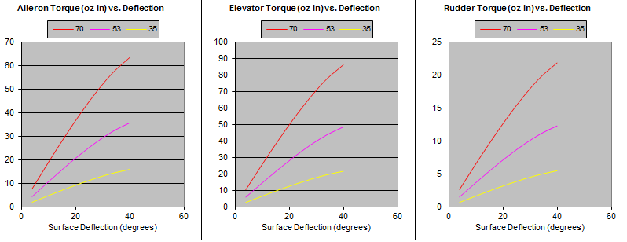
Figure 1: Torque vs Surface Deflection

3.3 Aircraft Sizing

3.3.1 Wing Geometry and Selection
There are geometric parameters to take in considerations when designing a wing, such as aspect ratio, wingspan, and wing planform. After looking at different types of wing planform such as elliptical wing, tapered wing, and rectangular wing, the team decided to select the rectangular wing because it is ideal for low speed aircraft, the easiest to design, build, and all airfoil ribs are the same, which will reduce the time consumed to build the wing. Another key parameter is the aspect ratio, according to reference [7] the team decided to have an aspect ratio around 6.4 and a wingspan of 83.125 inches. The wing area then could be calculated using this equation.
$$S=\frac{b^{2}}{A}$$

3.3.2 Airfoil Analysis and Selection
After comparing different number of airfoil, the team decided to select two airfoils to analyze which are the Eppler 423 and Clark Y. These airfoils were analyzed using Profili software; results are shown in Fig 2 and 3. The airfoil shapes are shown in the figures, Reynolds number is 300,000 and the angle of attack is set between 0 and 15 degree. Figure 2 is $C_{l}$ versus$∝$ for both airfoils, the $C_{l}$ of the E 423 is higher than the Clark Y. Figure 3 is $C_{d}$ versus $∝$, the figure is showing that the drag coefficient of E 423 is slightly higher than the Clark Y. The E 423 is a better choice overall due to the high lift coefficient.
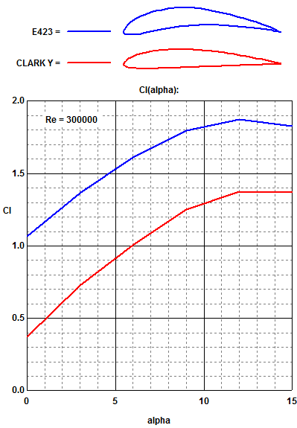
Figure 2: Lift Coefficient vs AoA
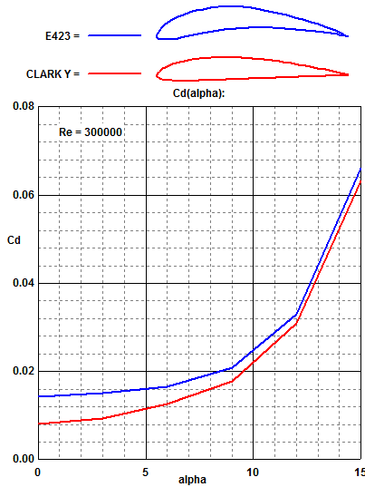
Figure3: Drag Coefficient vs AoA

The maximum lift to drag ratio of the E 423 and The Clark Y are shown in figure 4. The maximum $C_{l}/C_{d}$ of E 423 is 97 at angle of attack of $6°$ while for the Clark Y is 79 at angle of attack of$6°$. The higher the value of$C_{l}/C_{d}$, the more efficient the airfoil will be. [2] Therefore, the E 423 will be a better choice for the team.
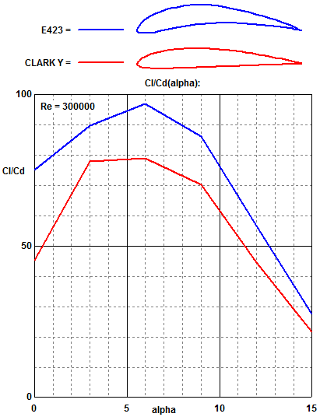
Figure 4: Lift to Drag Ratio

3.4 Weight Build Up and Analysis
The stability of the aircraft was determined by finding the center of gravity. We determined the mass of each component and measured the distance from the tip of the airplane to the center of gravity of each component. The equation used for the center of gravity goes as follows.
$$X_{CG}=\sum_{i}^{n}{\frac{{(w*d)}_{i}}{w_{i}}}$$
Where w is the weight of the component and d is the distance from the reference point to the components center of gravity. Below are the tabulated results of this analysis.
Table 5: Center of Gravity
Components | Weight (lb) | Distance (in) (x-direction) | Moment (in-lb)
Front Fuselage | 0.85 | 14.41 | 12.25
Wing | 2.59 | 16.05 | 41.57
Vertical Tail | 0.24 | 45.46 | 10.91
Horizontal Tail | 0.5 | 42.71 | 21.36
Engine | 1.45 | 3.66 | 5.31
Engine Mount | 0.1 | 4.92 | 0.49
Propeller | 0.2 | 0.75 | 0.15
Main Front Wheel | 0.42 | 4.9 | 2.06
Back Wheels | 1.02 | 19.91 | 20.31
Styrofoam | 0.2 | 15.66 | 3.13
Honey comb | 0.93 | 16.41 | 15.26
Gas Tank | 0.5 | 8.63 | 4.32
Tail Boom | 0.23 | 30.46 | 7.01
Payload | 20 | 14.79 | 295.80
COG without payload | 15.61 | inches from the tip of the airplane
COG with payload | 15.05 | inches from the tip of the airplane

3.5 Structural Analysis
The structural analysis of the wing loading due to lift forces is very important to make sure the wing will not break during lift off or in flight. The team decided to use the advantages of Solidworks simulations to get the stresses of the spars on the wing due to lift forces. The team decided to test the stresses using a distributed load lift force along the spars and also a point load lift force at the wing tip for worst case scenario. To find how much of the lift force was being applied to each of the 3 spars the team had to find the reactions for a statically indeterminate beam. [8] Once found the team knew the weight distribution of each spar and plugged the corresponding numbers into the Solidworks simulator to get the stress and displacement profiles (Figure 5). For worst case scenario the team put a point load of the entire lift force to get the maximum possible values for stress and displacement (Figure 6).

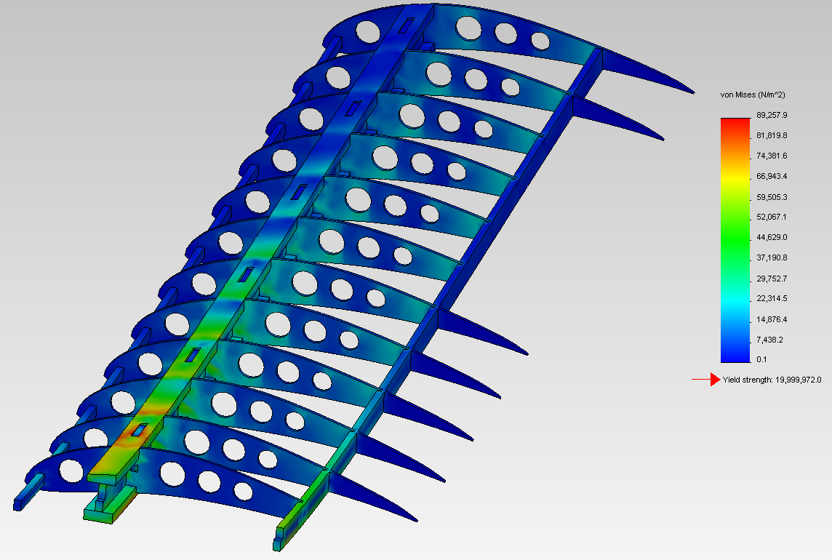
Figure 5: Distributed Load Stresses

Table 6: Structural Analysis Results of Distributed Load
Maximum Stress | Maximum Displacement
13 Psi | .02 Inches

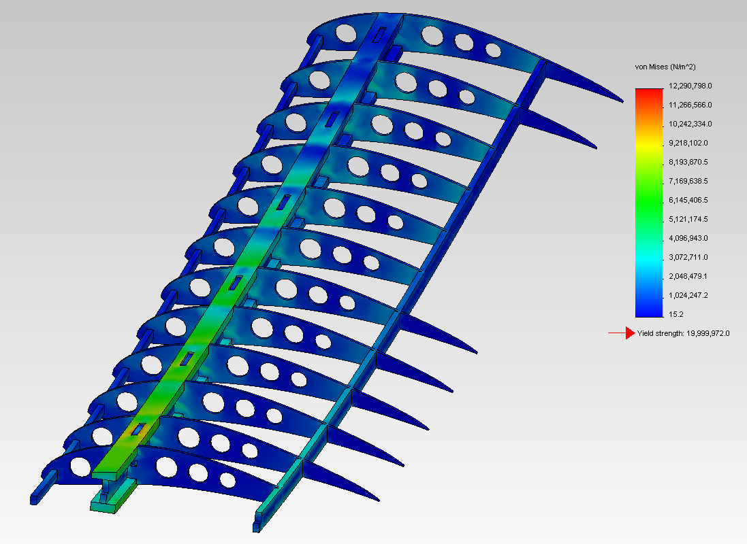
Figure 6: Point Load Stresses
Table 7: Structural Analysis Results of Point Load
Maximum Stress | Maximum Displacement
1780 Psi | 2 Inches

The results showed that our pressures for both scenarios are below the yield stress of balsa wood which is about 3000 Psi. With these results the team can determine that our wing assembly will easily hold the lift forces generated.
Next, the team decided to make sure the spars on the wing assembly would hold for the weight of the aircraft and the payload. Determined in the take-off distance section our maximum payload to take off within 200 feet is 22 pounds. Using this payload and the weight of the aircraft we solved the statically indeterminate beam problem as did before with lift forces. The stresses on the spars due to the weight of the aircraft and payload do not exceed balsa woods yield strength and therefore should not break.
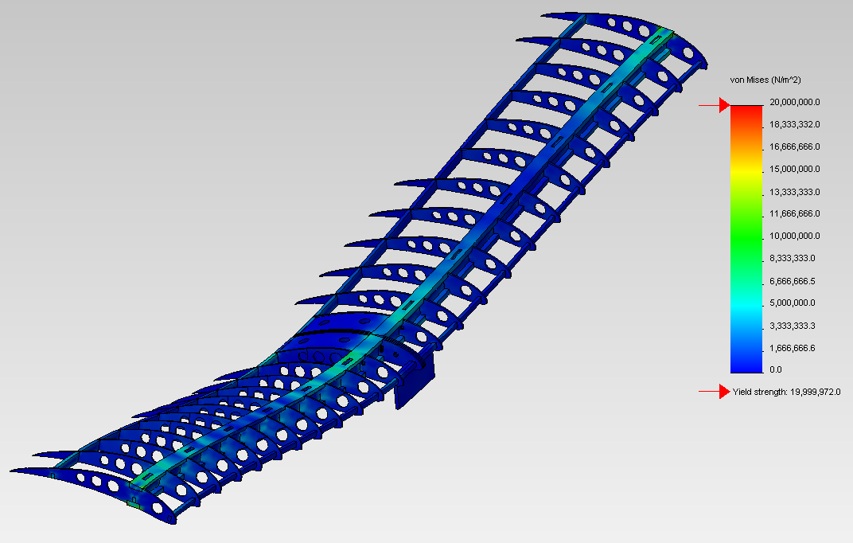
Figure7: Stress Due to Aircraft Weight and Payload
Table 8: Structural Analysis Results of Payload Loading
Maximum Stress | Maximum Displacement
2600 Psi | 1.1 Inches

4.0 Innovations

4.1 Construction Process
The airplane is currently in the process of being built. A CNC cutter will be used to cut the airfoils in the desired shape (E423). Another option that we have is a laser cutter at a local high school that we might be allowed to use if for whatever reason at some point we cannot use the laser cutter in the university machine shop. Everything else will most likely be cut by hand since the other components of the airplane do not require the near perfect precision that the airfoils demand.

4.2 Design Methodology
Up to this point we have had three major steps in this project. The first step was strictly conceptual since we had very little to work with. We researched previous competitions and we took into consideration the components that made certain teams successful. A highly important part of the design methodology was to choose an airfoil that would work well with the type of airplane we are constructing. Profili 2 was the software that was used in the decision process of airfoil. After testing a number of different airfoils on this software we decided that the E423 airfoil would be the best choice for our airplane since it contains a high lift capacity. The second step in this methodology was to build a model of the airplane in Solidworks for further analysis of the airplane. This second step was crucial to gain knowledge of the small parts of our airplane and how the components would fit together. The third step was to complete a structural analysis of the airplane. This was necessary because this gave us knowledge of the different stresses on our wing and where these stresses are located. After these steps were completed we had to return to our original calculations and replace the assumed values with actual values. After doing this, we had a much better understanding of our airplane as a whole.

4.3 Applications
There are a few different kinds of applications that can be carried out using an RC airplane. Aesthetics are a large part of RC airplane applications. It can be a bonding experience for a father and son project and a great “hands on “ experience for a child who is interested in the basics of engineering and science. There is a wide variety of RC airplanes in the market due to their low cost and ease of construction.
Another application of RC airplanes would be for military use. Advancements in technology have made it possible for cameras to become extremely small, resilient and versatile. A small camera can be attached to the airplane and be used for a reconnaissance mission to gain knowledge of a certain terrain or to see if an area is safe for troops to move into. Instead of placing a camera in the airplane, a message can easily be relayed back and forth using these RC airplanes. A more aggressive take on this could be to make the payload of the RC airplane be an explosive and be flown into enemy grounds and detonate it when needed. A very helpful application could be to fly an RC airplane into an area that has been severely damaged by a natural disaster to see if it safe for rescuers to enter the area to look for survivors.

4.3 Use of Computer Aided Design
Profili 2 was used to decide which airfoil would be the best fit for our airplane. It was used to calculate pressure and force distribution on our airfoils. It was also instrumental in analyzing the aerodynamics of the airfoils. Microsoft Excel was used while we were calculating the payload weight vs. altitude values, thrust values and drag values.
A complete model of our airplane was made using Solidworks 2011-2012 CAD. This model contains every detail that is relevant to the airplane. After the construction of this model in Solidworks we needed to calculate the stresses on the wing of the airplane. Since the stresses on the wing were calculated by hand, Solidworks gave us the exact dimensions of the components that were being analyzed. These exact dimensions allowed us to calculate exact stresses and exact locations of these stresses.

4.4 Electrical Design
A highly important aspect of this project is to have fully functional and integrated electrical system. This electrical system contains a number of different contraptions such as a radio, a receiver, servos and a battery. The regular class of the SAE competition has a small number of requirements for the electrical system. These requirements are that the battery must have a minimum capacity of 1000mAh (milliamp-hours). The SAE competition also mandates that the radio that we are using for flight be at an operating frequency of 2.4GHz. The final requirement from the competition is that we have an analysis of the servos that we used to make sure that they are adequate for the maneuvering that our airplane will be doing.
A receiver that satisfies the SAE requirement will need to be purchased. The receiver is the Spektrum AR6000; it contains six channels that are available for servos. This gives us a number of options when setting up servos for different components of our airplane. Unfortunately, we could not salvage functional servos from previous years so these will have to be purchased. The controller that was used in previous years is still functional and a battery was found in the container that that the controller was in so we will not have to worry about purchasing either of these two components.
To maintain a satisfactory design the location of each electrical component had to be thoroughly considered. The receiver will be placed in a small area on the front of the fuselage. The battery will be further back on the fuselage where the fuselage begins to incline upward. The reasoning behind this is if the receiver and the battery were too close to each other there would be electrical interference between both components.
We will place two servos for each aileron on both wings, one servo for the elevator on the tail, and one servo that connects the front wheel and the rudder. We felt it necessary to have one servo for each aileron because these will be helpful when the airplane is turning. During a turn, the ailerons will be alternating directions. Having one servo for each aileron will facilitate the manipulation of the ailerons during turns

References
- Rules and Important Documents. http://students.sae.org/competitions/aerodesign/rules/
- Anderson, John D., fundamentals of Aerodynamics, McGraw-Hill, New York, 2011
- B. W. McCormick, Aerodynamics, Aeronautics, and Flight Dynamics, John
Wiley, 1995
- Garner, W. B., “Model Airplane Propellers” 2009
- Nicolai, Leland M., Estimating R/C Model Aerodynamics and Performance, Lockheed Martin, 2009
- Aircraft Proving Ground. -http://www.geistware.com/rcmodeling/calculators.htm
- Raymer, Daniel P., Aircraft Design: A Conceptual Approach, American Institute of Aeronautics and Astronautics, Virginia, 1999
- Philpot, Timothy. Mechanics Of Materials. Hoboken: John Wiley and Sons Inc, 2008. 411-421.
- Anderson, John D., aircraft performance and design, McGraw-Hill, New York, 1999

Appendix A
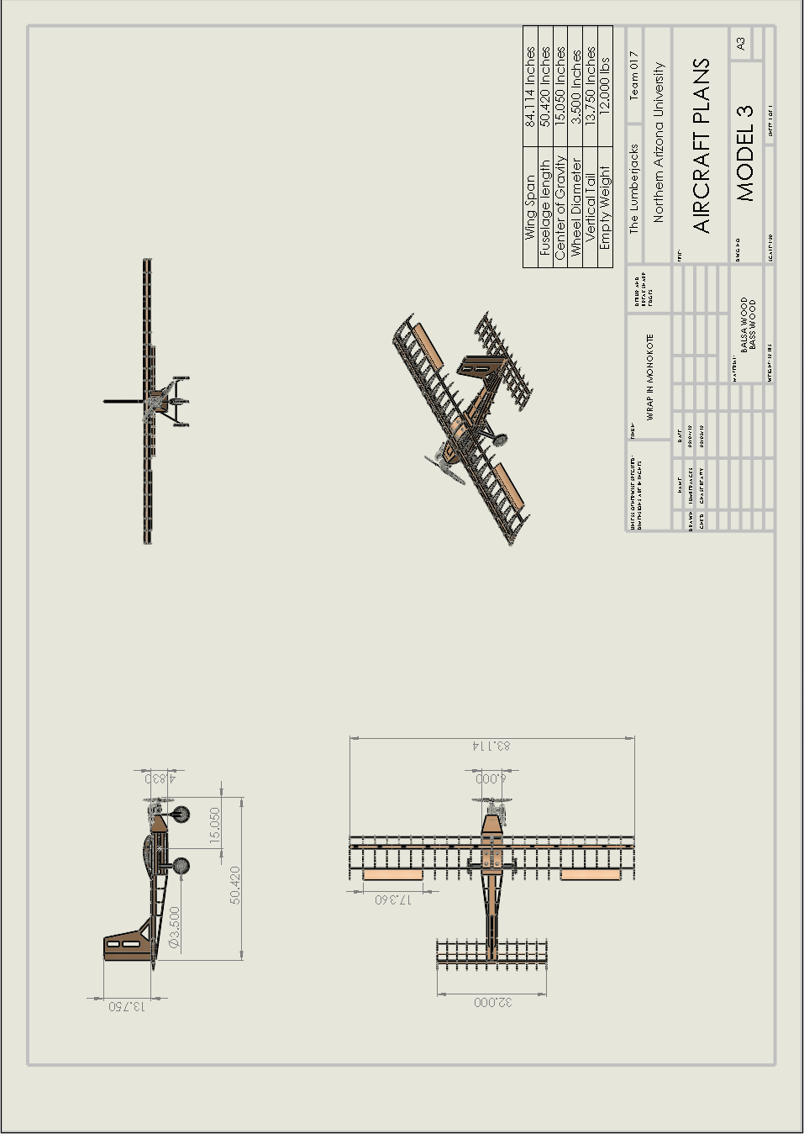

Appendix B

